JENKINS Successful Build

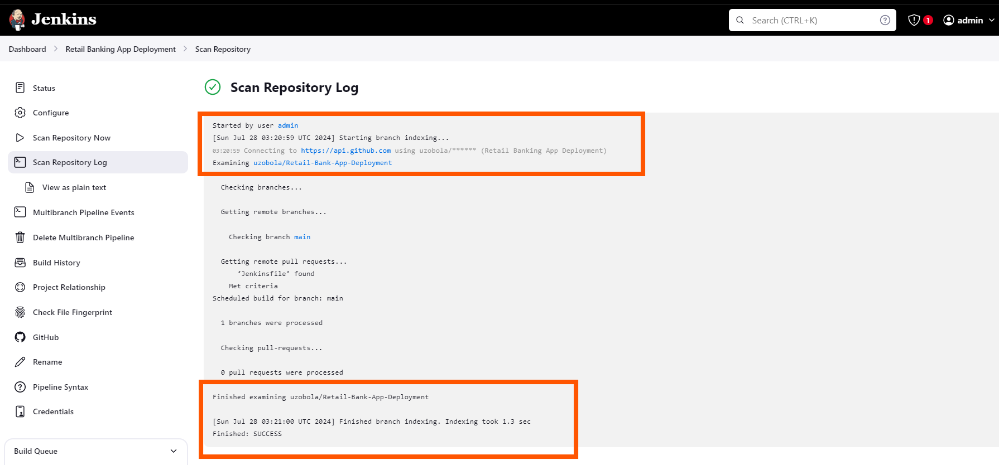

**"ISSUES/TROUBLESHOOTING"**

**ISSUE #1**

I got a 502 Bad Gateway error pointing to the fact that it was a server-side error.

**ISSUE #2:**

For some reason, I could not get the logs from the console

**TROUBLESHOOTING STEPS:**

-Checked the server logs and found out from **/var/log/nginx/error.log** that although it was trying to listen on port 8000 nothing was running on that port.  


Out of the many overkill steps I took, these are the steps that I believe were successful:  
#1 Installing/re-installing gunicorn (pip install gunicorn)

**#2** Starting the application with python.

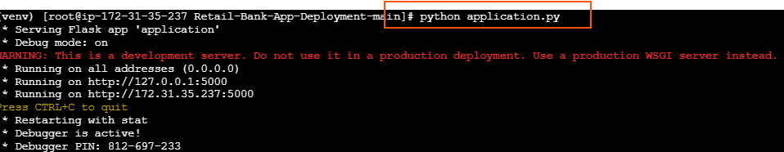

**#3** Mapping the port 8000/ starting the application with gunicorn ( gunicorn -w 4 -b 127.0.0.1:8000 application:application )

**# Success!!**



**#Retail Banking App Landing Page**

